**OUR PRODUCTS**

[](https://eapp.com.my/product-page/ambient-whip/)

[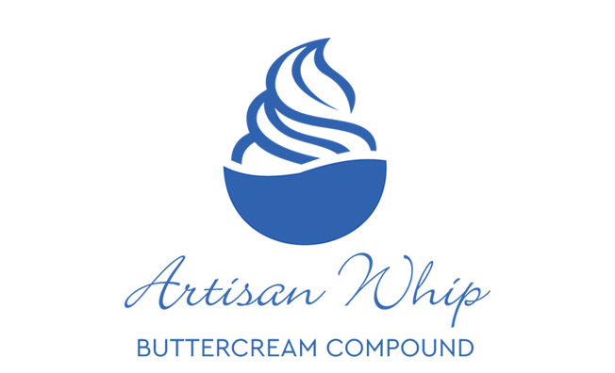](https://eapp.com.my/product-page/artisan-whipping-cream-cake-decoration-filling/)

[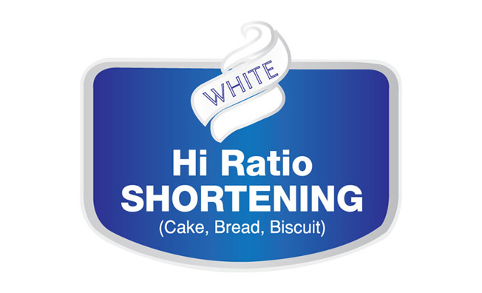](https://eapp.com.my/product-page/cryspol-icing-shortening/)

[](https://eapp.com.my/product-page/breadmate-emulsified-breadfat/)

[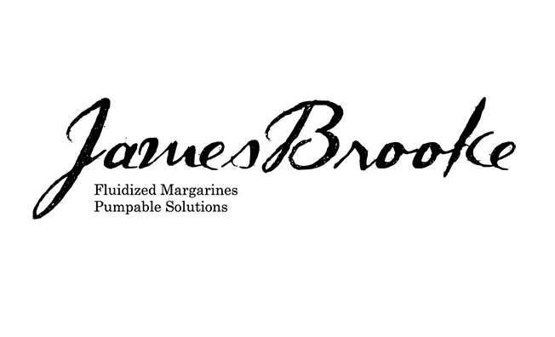](https://eapp.com.my/product-page/james-brooke-fluidized-margarine-shortening-cake-oil/)

[](https://eapp.com.my/product-page/oliobutta-butter-blends-substitute-replacer/)

[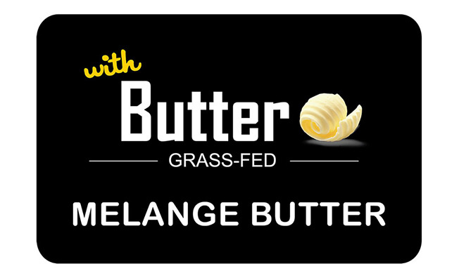](https://eapp.com.my/product-page/brooke-butter-blends-melange-butter-la-patissier/)

[](https://eapp.com.my/product-page/easybake-specialty-cake-margarine/)

[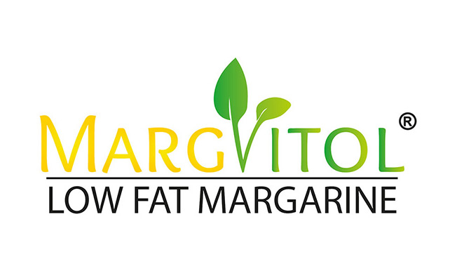](https://eapp.com.my/product-page/margvitol-butter-flavored-bakery/)



[](https://eapp.com.my/product-page/eanrich-butter-oil-substitutes/)

[](https://eapp.com.my/product-page/mlkfar-anhydrous-milk-fat-replacer/)

[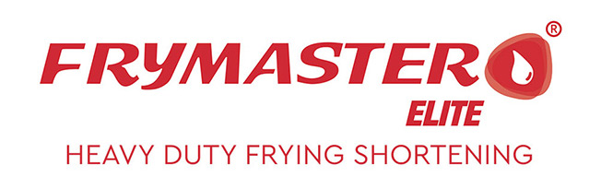](https://eapp.com.my/product-page/frymaster-vegetable-palm-olein-frying-oil/)

[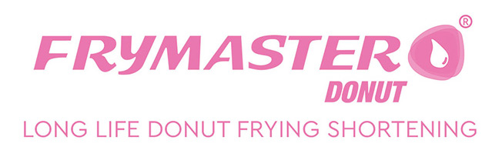](https://eapp.com.my/product-page/frymaster-donut-vegetable-fat-for-frying-donut/)

[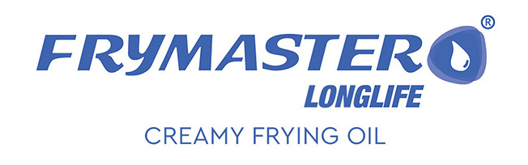](https://eapp.com.my/product-page/frymaster-long-life-heavy-duty-creamy-frying-oil/)

[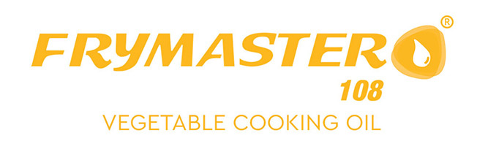](https://eapp.com.my/product-page/frymaster108-vegetable-cooking-oil/)

[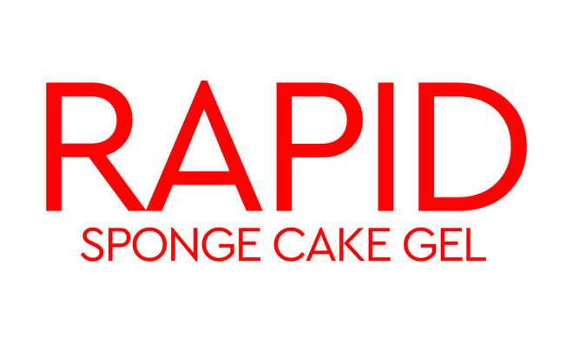](https://eapp.com.my/product-page/rapid-brooke-sponge-sp-cake-gel-ovalett-special/)

[](https://eapp.com.my/layout3/product-page/kylie-pan-release-agents/)

[](https://eapp.com.my/product-page/owen-pan-release-agents/)

[](https://eapp.com.my/product-page/excel-dough-division-oil-slicing-machine/)

[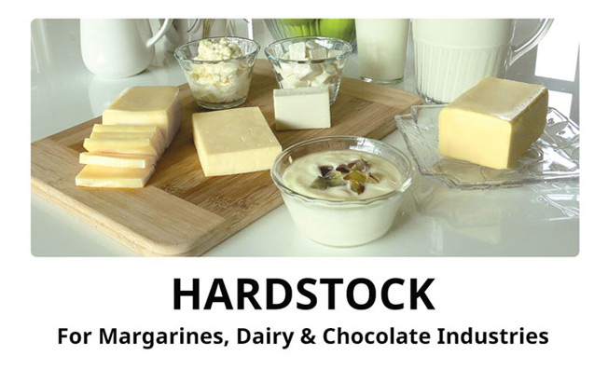](https://eapp.com.my/product-page/hardstock-cbs-whitefat-elite-milk-fat-replacer/)

[](https://eapp.com.my/product-page/heritage-sheet-laminating-margarines-and-spreads/)

[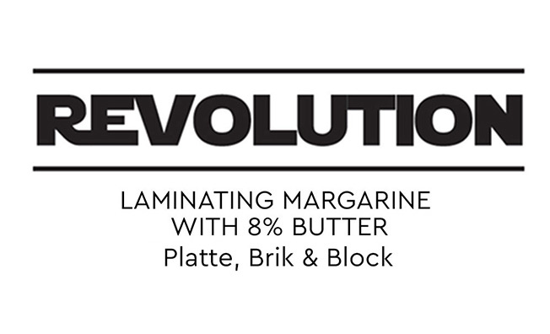](https://eapp.com.my/product-page/revolution-sheet-laminating-margarines-and-spreads/)

[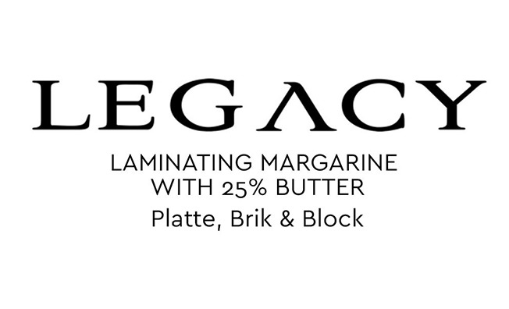](https://eapp.com.my/product-page/legacy-sheet-laminating-margarines-and-spreads/)

[](https://eapp.com.my/product-page/ghee-oil-turmeric-specialty-ghee/)

[](https://eapp.com.my/product-page/ghee-beurre-melange-buttery-taste/)

[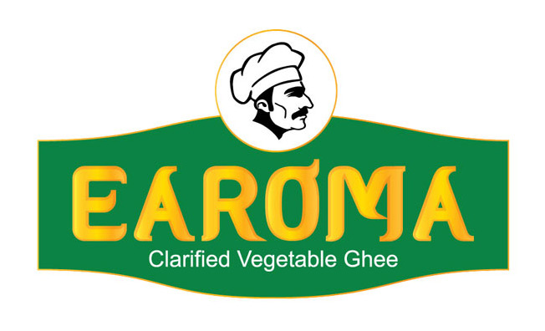](https://eapp.com.my/product-page/earoma-vegetable-ghee/)